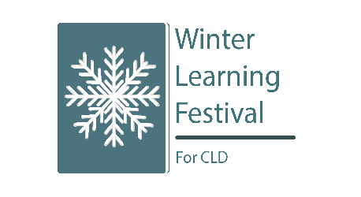
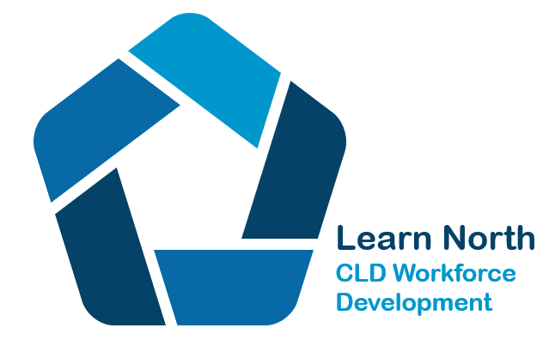
Winter Learning Festival Event List

Learn North Events Monday 31st October - Friday 4^{th November}

Standards Council i-develop link to full programme https://www.i-develop-cld.org.uk/course/view.php?id=195&section=0

Title | Date | Time | Registration Link
1.Introduction to CHIME; creating and measuring mental health impact in communities  Heidi Tweedie, Moray Wellbeing Hub | Monday  31st October 2022 | 11.00-12.30pm | Email to book a place  Karen.Delaney@moray.gov.uk
2.Creative Voices – tools and resources for creative engagement and delivery in community settings  Designed by Aberdeenshire CLD Service | Monday  31st October 2022 | 2.00pm  Online launch |  | View online from 2pm when launched
 | https://sites.google.com/aberdeenshirecld.co.uk/creativecommunityvoices/home
3.An introduction to Gaelic  Mira Byrne, Western Isles Council | Tuesday  1st November  2022 | 1.00—2.00pm | Email to book a place  mbyrne1u@gnes.net
4.Putting the Michael Fullan right drivers into action in the North  Kathleen Johnston – Quality Improvement Manager Northern Alliance Regional Improvement Collaborative | Tuesday  1st November  2022 | 3.00-4.00pm | Email to book a place  sue.briggs@aberdeenshire.gov.uk
5.Outdoor Family Learning in New Pitsligo – Aberdeenshire  Melanie Johnston – CLDW Aberdeenshire Council | Wednesday 2nd November  2022 | 4.00 – 4.45pm | Email to book a place  melanie.johnston@aberdeenshire.gov.uk
6.An introduction to the CLD Standards Council  Robbie Crow – CLD Standards Council | Wednesday 2nd November  2022 | 6.00-7.00pm | https://www.eventbrite.co.uk/e/cld-standards-council-an-introduction-to-the-cld-standards-council-registration-443134777047
7.Youth Volunteering Pathways – Partnership working in CLD and Third Sector in the  Western Isles  Suzanne Macauley – Manager, Volunteer Centre Western Isles | Thursday  3rd November  2022 | 12.00-1.00pm | Email to book a place  suzanne@volunteercentrewi.org
8.Taking a closer look at Community Based Adult Learning  Professor Lyn Tett – Edinburgh University | Thursday  3rd November  2022 | 4.00-5.00pm | Email to book a place  Sue.briggs@aberdeenshire.gov.uk  Advance support materials tbc
9.Using Thing-Link as a tool to speak about parenting with families when English is not their first language.  Emma McPherson – Aberdeen City Council | Friday  4th November | 10.00–11.30am | Email to book a place  EMcPherson@aberdeencity.gov.uk  Advance support materials tbc
10.“Back on our Feet” Moray’s participatory budgeting with young people  Fiona Herd – Child and Families Manager Moray Council | Friday  4th November  2022 | 1.00 -1.45pm | Email to book a place  Karen.Delaney@moray.gov.uk

Wider events available over the winter of 2022/23 through the:

- Southeast & Central Consortium
- Tayside & Fife Professional Learning Alliance
- West Alliance
- Southwest Alliance
- Education Scotland
- CLD Standards Council

Access details via this link:

https://www.i-develop-cld.org.uk/course/view.php?id=195&section=0

